Seg-MEN-TAT-ion Rep-ort
28430093 Alwyn Barnard ITRW 316 2019 Mr Henry Foulds

Table of Contents
Introduction 2
How does it Work? 2
Translating a Logical Address into a Physical Address with the Segment Table 3
Advantages and Disadvantages of Segmentation 4
Advantages 4
Disadvantages 4
Conclusion 4
References 5

Introduction
Segmentation consists of a technique deployed in memory management that divides each job into several segments of different sizes. Each segment is actually a different logical address space of the program. These segments all contain related information of the segment piece before and the segment piece following behind it.

The key difference between segmentation and paging is that the segments are of variable length. In paging, the segments or parts are all of fixed size. A process Segment Table is used to keep track of each individual segment, its size, and memory address (Tutorialspoint, 2019).

How does it Work?
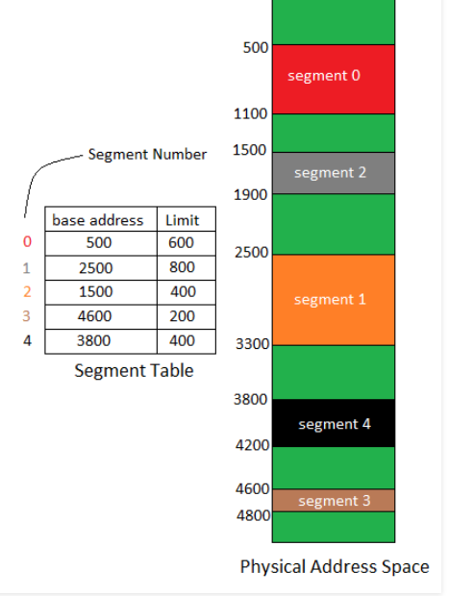
(Jain et al., 2019)
The Segment Table shown above maps a two-dimensional Logical address to the one-dimensional Physical address in memory. In the Segment Table there are two columns (only representative, not physically in memory), one contains a base address (The physical starting point address where the segment starts in memory). The second column contains a limit, or size of the corresponding segments.

The logical address in memory links to the segment table, which references the base address. From the base address the CPU calculates the size or end of the segment by using End = base address + limit. From there the physical position in memory is retrieved (Jain et al., 2019).

Translating a Logical Address into a Physical Address with the Segment Table

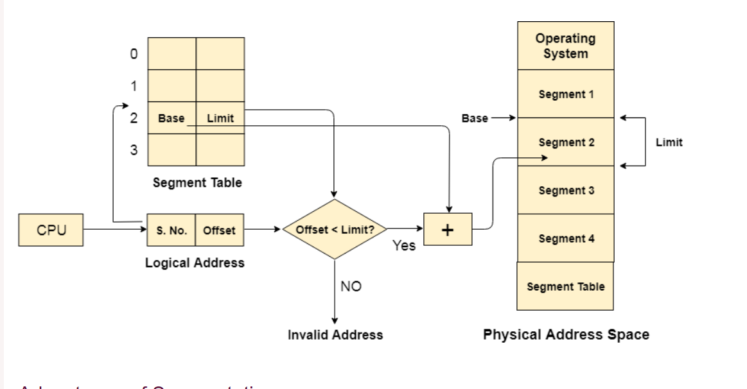
(Javatpoint.com, 2019).
The CPU of the computer generates a logical address consisting of two features: a Segment Number and an offset. The Segment Number maps to a Segment Table and the limit of that segment is compared to the segments limit then the address is valid, or it throws an invalid address error. If the address is valid then it maps to a physical address in memory (Javatpoint.com, 2019).

Advantages and Disadvantages of Segmentation

Advantages
- Segment Sharing is possible where with paging it is improbable.
- It is easier to relocate a segment rather than an entire program.
- Unused memory won’t need to be allocated and can be left empty.
- There is a small segment table in the MMU (Memory Management Unit).

Disadvantages
- With variable length segments, some segments may not fit.
- Large segments cause Fragmentation.

Conclusion
Segmentation is a technique that allows the CPU to implement paging but with a variable sized segment. The key differences between paging and segmentation lies in the way the address looks, the size of the pages and the use of a segment table over a page table.

References
Jain. S., Bajpai. V., Goel. S., Singh. D. & Baranwal. S. 2019. Operating system | segmentation. https://www.geeksforgeeks.org/operating-systems-segmentation/ Date of access: 12 Mar. 2019.
Javatpoint.com. 2019. Segmentation. https://www.javatpoint.com/os-segmentation Date of access: 12 Mar. 2019.
www.tutorialspoint.com. 2019a. Operating system – memory management. https://www.tutorialspoint.com/operating_system/os_memory_management.htm Date of access: 12 Mar. 2019.

